

**“Concert ticket sales web application”**

Names : 1. Ahmad Fathon Nurhayusuf

2. Mutia Rahma Alifah

3. Salwa Widyna Khairani

Faculty : Mrs. Bayu Citra Nur Aulia S.T., M.TI.

Class : 2WD1

**CEP CCIT**

**FAKULTAS TEKNIK UNIVERSITAS INDONESIA**

**2023**

# PREFACE

First of all, Thanks to Allah SWT for helping and giving us a lot of motivation to complete this project, peace, and salutation may also be upon the most honorable prophet Muhammad SAW, who had taught us that there is nothing more precious than seeking knowledge.

**Concert ticket sales web application**

Batch Code : 2WD1

Start Date : June 21, 2024

End Date : July 01, 2024

Name of Faculty : Mrs. Bayu Citra Nur Aulia S.T., M.TI.

Names of Developer :

1. Ahmad Fathon Nurhayusuf

2. Mutia Rahma Alifah

3. Salwa Widyna Khairani

Date of Submission : July 01, 2024



# PROJECT ON

**Ticket concert application**

**Developed by**

1. Ahmad Fathon Nurhayusuf

2. Mutia Rahma Alifah

3. Salwa Widyna Khairani

# CERTIFICATE

This is to certify that this report, titled “Concert ticket sales web application”, embodies the original work done by Ahmad Fathon Nurhayusf, Mutia Rahma Alifah, and Salwa Widyna Khairani, in partial fulfilment of their course requirement at NIIT.

Coordinator:

Mrs. Bayu Citra Nur Aulia S.T., M.TI.

# ACKNOWLEDGEMENT

The authors want to praise Allah, the Most Merciful, and that the authors can complete Project 4 entitled “Concert ticket sales web application”. We would like to thank our faculty Mrs. Bayu Citra Nur Aulia S.T., M.TI., who has given us useful advice that helped us in writing this article.

The authors recognizes that this paper is far from perfect, therefore, all criticisms and suggestions from readers will be welcomed by the authors in order to improve the manuscript of this research further. The authors express his gratitude to all those involved in writing this script.

# BACKGROUND

In an era where live entertainment is increasingly popular, concert ticket sales have become increasingly important. However, the ticket sales process is often inefficient, leading to long lines, limited accessibility, and the risk of fraud.

To overcome these challenges, the development of a concert ticket sales app is the expected solution. Through a sophisticated digital platform, the app will make it easier for users to purchase tickets online, increase accessibility, and reduce the risk of fraud. With the latest technology, the app aims to revolutionize the concert ticketing experience, providing benefits to users, promoters, and artists.

# SYSTEM ANALYSIS

System analysis of this project using the Javascript, CSS, HTML, and JSP programming system. The goal of this project is to create a system on the web in the form of purchasing concert tickets, which aims to make it easier for visitors who want to buy concert tickets but do not have to buy on the spot.

# Technology Diagram

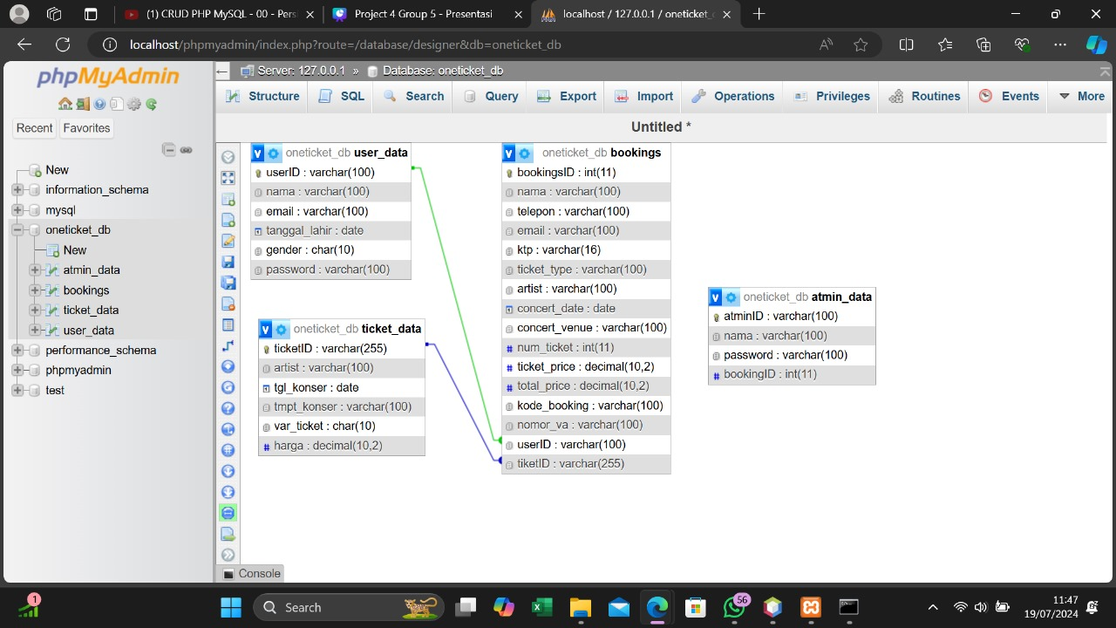

This diagram illustrates the navigation structure of a connection or relationship between all table. There are several features in this web application such as Home, Venue, Category, Artist, Ticket payment, Admin log in, and Log in.

# HTML PAGES

1. **Home Page**

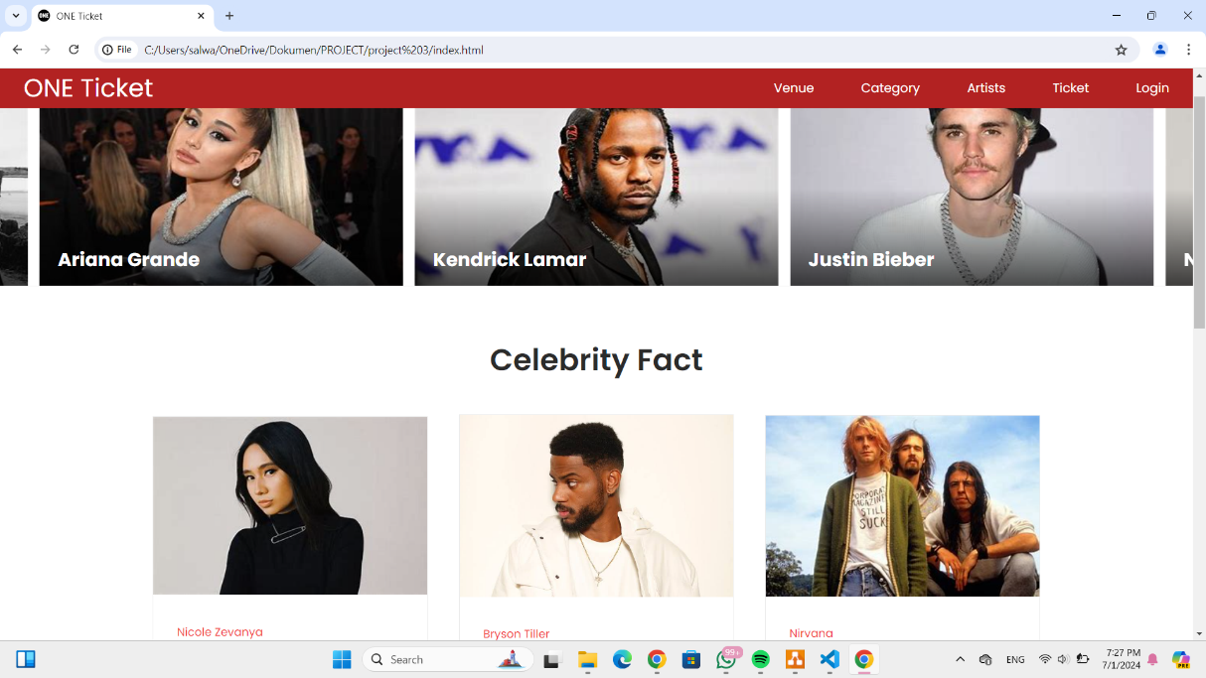

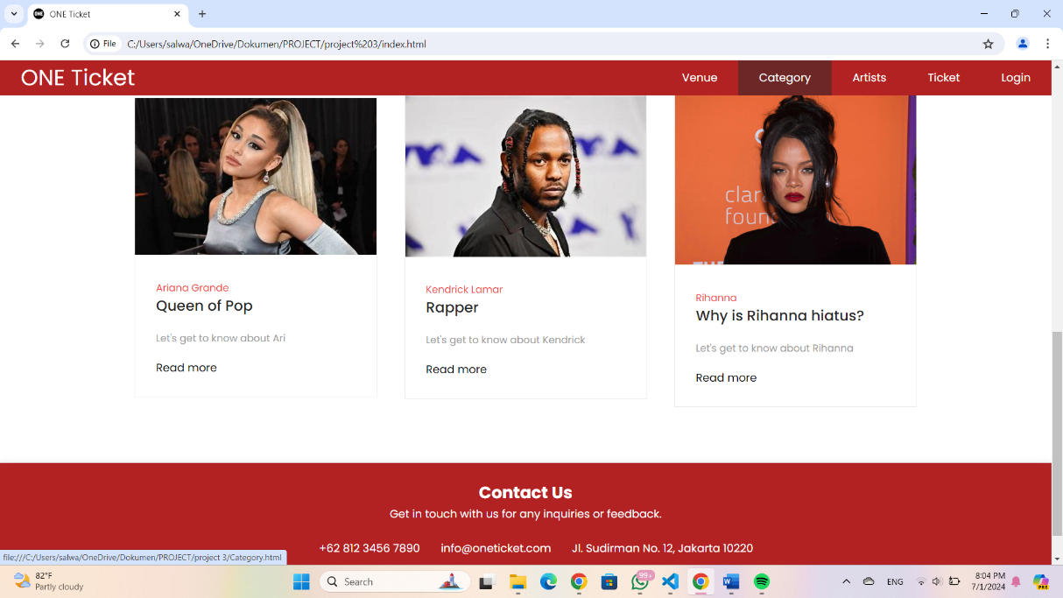

1. **Venue**

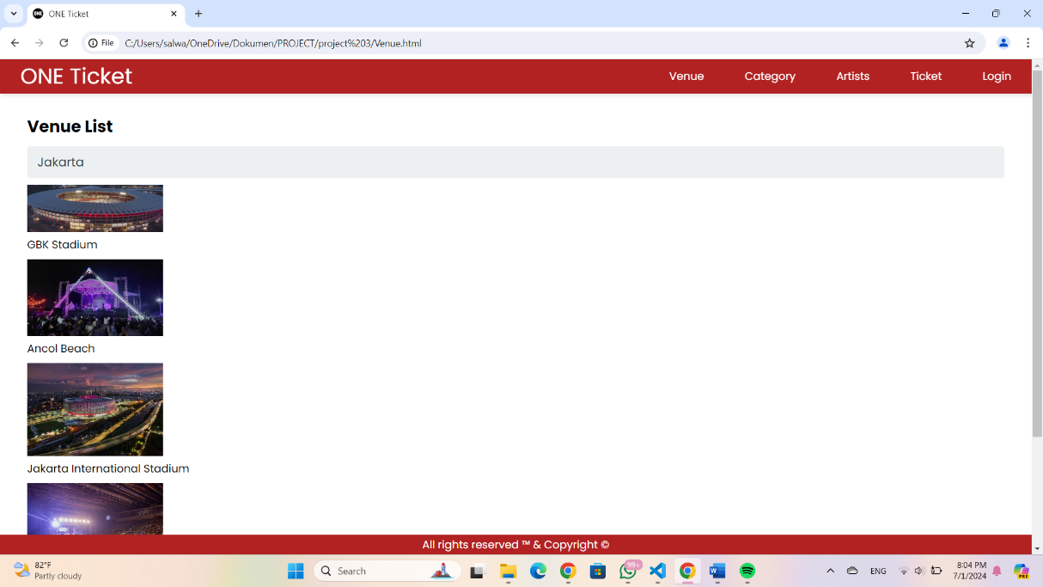

1. **Category**

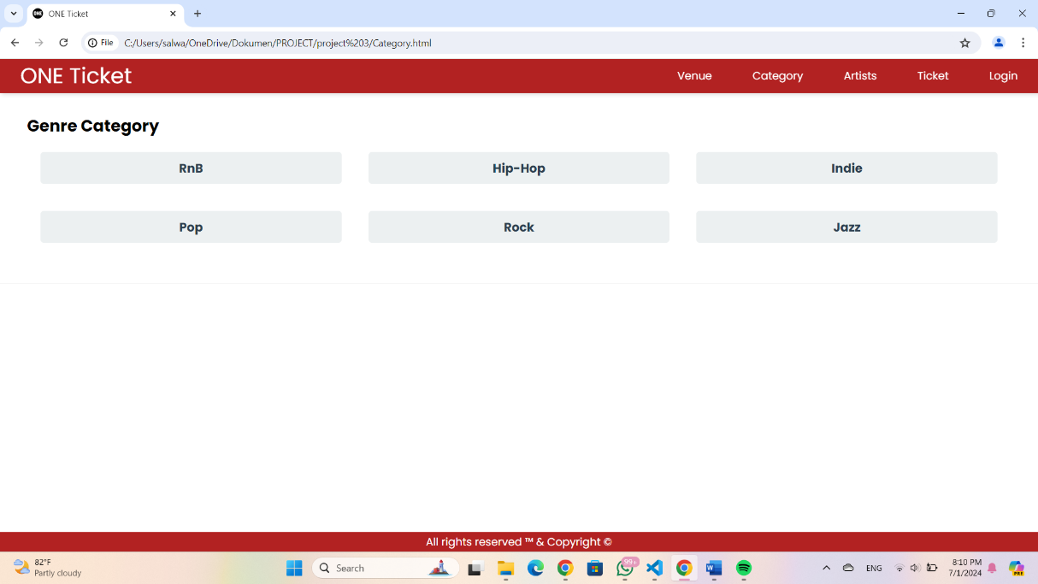

1. **Artist**

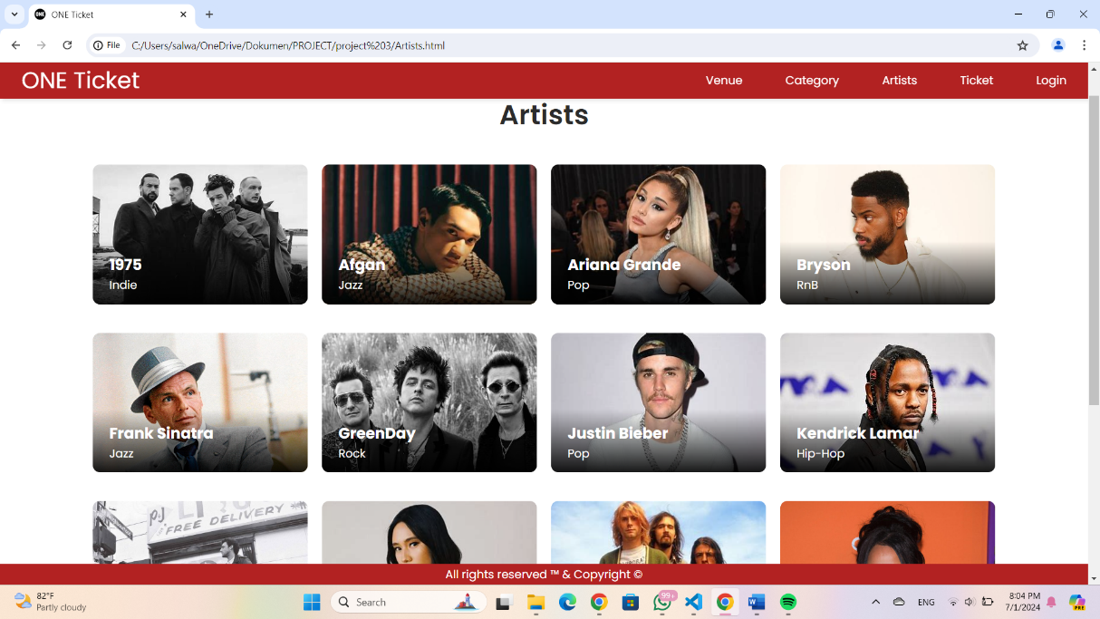

1. **Ticket**

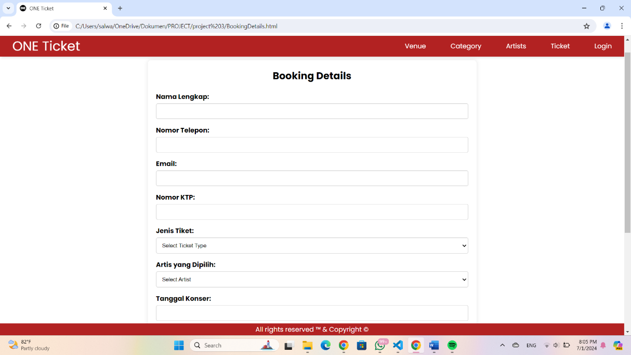

1. **Receipt**

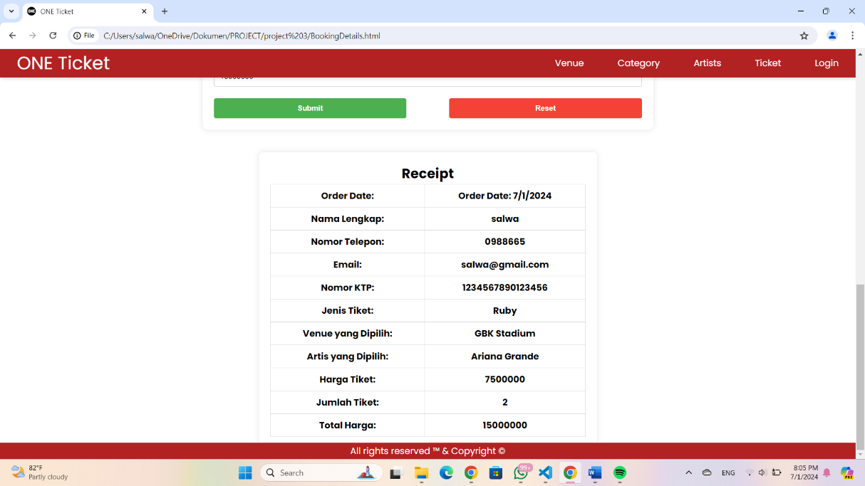

1. **Log in**

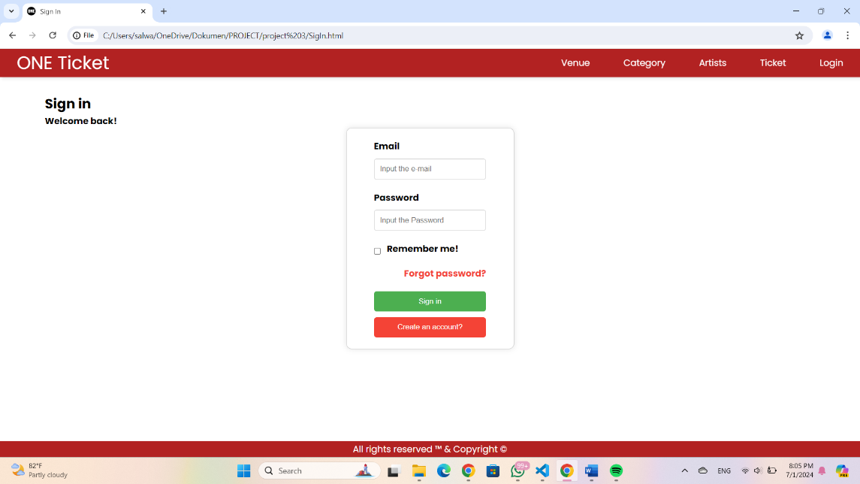

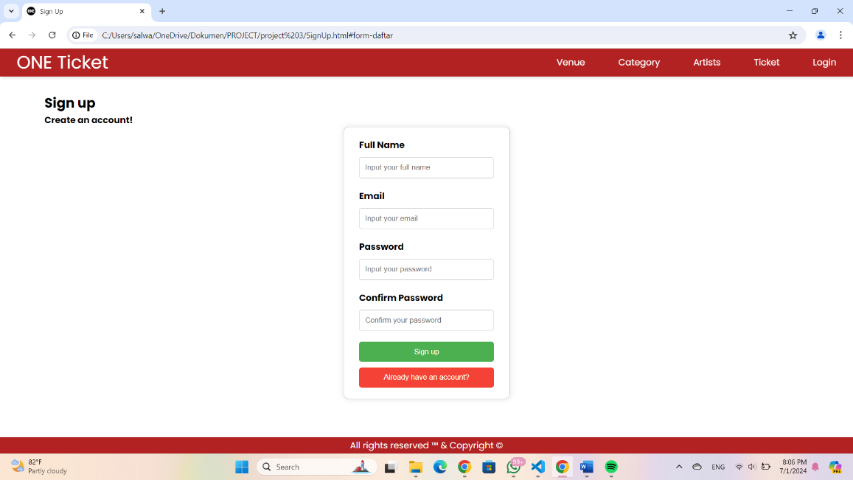

# Configuration

**Hardware** **:** Asus TUF Gaming F15, Thinkpad, Asus Vivobook

**Operating System** **:** Windows 11

**Software :**  Apache Netbeans, Xampp, MySQL

|  |  |  |
| --- | --- | --- |
| **PROJECT FILE DETAILS** | | |
| S.No | File Name | Remarks |
|  | Project 4 Group 5.docx | File from Microsoft Word for explain and introduction our project |
|  | Project 4_OT.rar | File From Visual Studio Code for implementation the code and build the company profile website. |
|  | Project 4 Group 5.pptx | File From Power Point for presentation. |